JOBSHEET 1



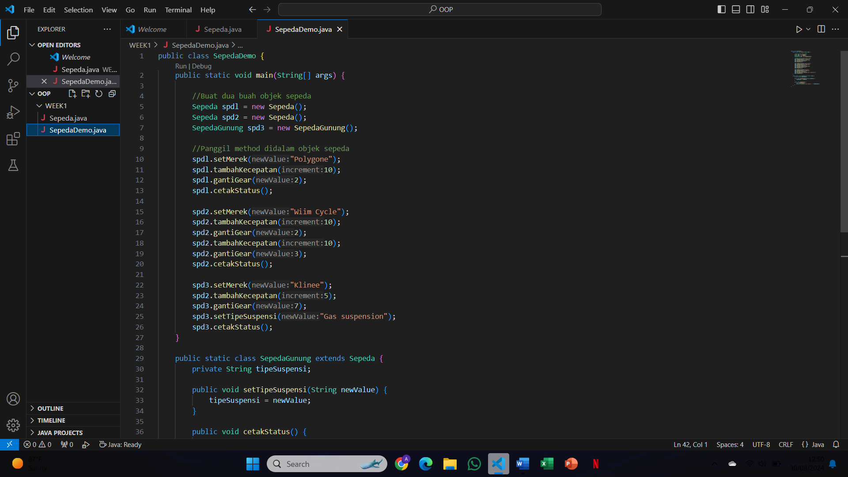





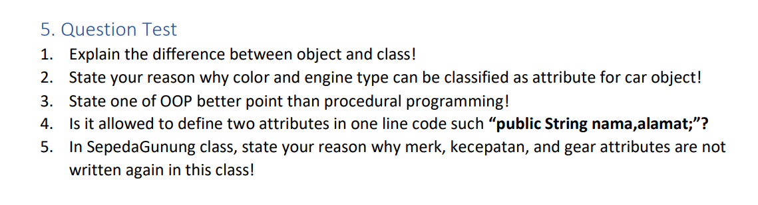

Answer



* Class is like a blue print or template for object creation. This strictly defines what kind of properties (attributes) and behaviors (methods/functions) the objects made from this class will have. For example while a Car class MAY HAVE attributes such as color or engineType and methods like drive(),stop() etc
* Object: Object is the an instance of a class. In a nutshell, an OBectification is simply an instance of the class with actual values for their defined properties. Object: A specific Car like myCar with color = "red" and engineType = V6 if Car is a class

1. Color and engine type are attributes of car object because they basically define the properties that tell us what is a car. Attributes are characteristic which differenctiat the object from other. Both colour and engine type are just two of the countless characteristics that sometimes set a car apart from all others on the road
2. Encapsulation One of the main pillars of Object Oriented Programming (OOP) is Encapsulation. Encapsulation enables bundling of data (attributes) and methods that operate on the data into a single unit, or class. This will make sure for better data security and utmost a type of less complexity, hiding the internal implementation details internally by only revealing what is actually needed via public interface
3. Yes, to define more than 1 attribute in one line of code? The line public String nama, alamat; is legal and makes the two string variables nama and alamat publicly accessible attributes of the class
4. The attribute merk, kecepatan and gear is not restated anymore in SepedaGunung class since that the you have implemented inheritance so this will automatically inherit again from its Base Class (Sepeda) Thanks to inheritance, the SepedaGunung class will automatically have access attributes and methods defined in the parent class (in this case it is Sepeda), useful so that we do not repeat writing similar code for our project.

